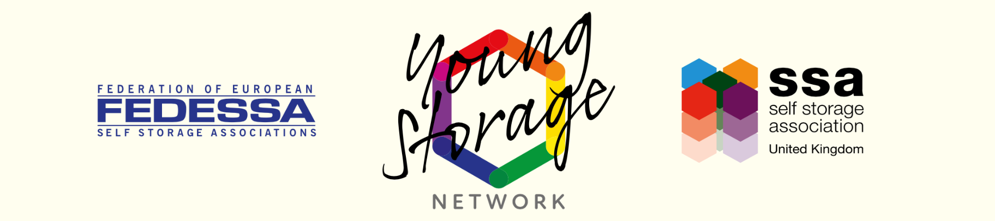
YSN Operator Member of the Year 2023

Mandatory requirements
- The company must be a member of SSAUK.
- The YSN member must be an operator member and have been employed at the company for at least 6 months.
- The YSN member cannot have a significant financial interest in the ownership of the property or business.
- Entries must be provided in an electronic version; Word document or pdf are preferred.
- A signed permission to publish form must be included with each entry.

Format of the entry
- Place the YSN member name and store name at the top of the first page.
- Explain how the YSN member’s performance has impacted the business.
- Provide some background on the store, such as its size, location and history.
- Provide supporting evidence to show the YSN member’s performance against relevant KPIs.
- Provide a good quality photo of the YSN Member.
- Use clear concise wording and paragraphs. Remember that the judges will be reading lots of entries, so make it as easy to read as possible and consider using a summary to make your key points stand out.

Judging Criteria
You should consider the following judging criteria when submitting your entry. The judges are looking for an outstanding YSN member and they will use the following criteria to help them decide between the finalists. If your YSN member has done something special that is outside these criteria then detail this but also cover the selection criteria.

Sales success
If the candidate works in a sales role how have they performed in terms of sales. This should include all areas associated with sales including but not limited to enquiry conversion rates, insurance sales success and other revenue streams. If the candidate does not work in a sales role, what contributions have they made that have indirectly increased company sales.

Customer Service
Providing customers with fantastic customer service is a great way to provide great value. How has the candidate performed when communicating with customers? Customer testimonials and reviews can help this category.

Operational Competence
How effective are they at completing the daily, weekly and monthly tasks required to operate a self-storage facility? How well have them performed when audited?

Teamwork
How well has the YSN member integrated with the company’s other employees? Are they a team player or are they more effective when left to get on with things?

Innovation
How has the YSN member been innovative in the way that they work? Have they utilised software or processes outside of those that were in place when they started?

Manager’s Input
Whilst the above categories will help us store the candidate we would also like their manager to provide feedback about their performance.
------
In addition, the judges may request a mystery shop, or organise a personal visit of some or all of the finalists to assist them in the judging process, or to verify the information provided.
If you have any questions about completing this entry please contact the YSN by emailing ysn@ssauk.com or calling 01270 623 150.

Good Luck!

